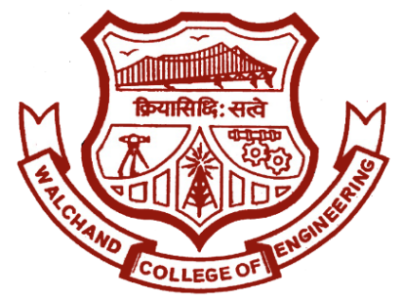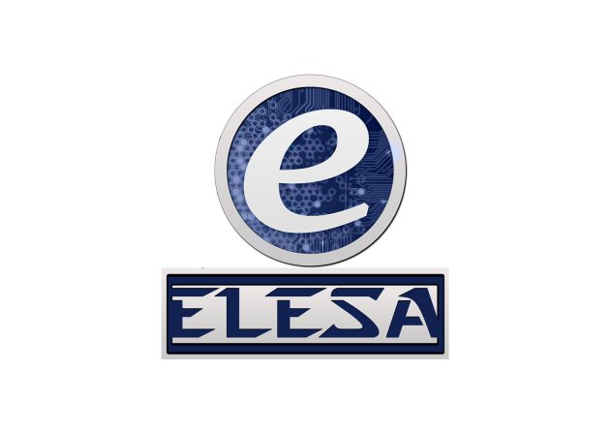

**Walchand College of Engineering, Sangli.**

(An autonomous institute)

&

Electronics Engineering Students’ Association (ELESA)

Presents

ELECTROVERT 2019

The Performers’ creed

To,

iYouthMag

**Subject**: Regarding the sponsorship for the **‘ELECTROVERT 2019’,** State Level Technical Symposium scheduled in the month of September, 2019.

Dear Sir / Madam,

Walchand College of Engineering, Sangli is one of the prestigious institutes in in Maharashtra, India and has been excelling for last 67 years since its inception.

Electronics engineering students’ association (ELESA) is a technical club of Walchand college of engineering, Sangli established in the year 1992 and has a trademark feature of reinventing itself every time. Our goal is to organize professional and social activities to strengthen and enrich the community and help to publicize various research activities.

We organize technical as well as social events and serve as a mediator between the students and industries. Every year we organizes a **State Level Technical Event ELECTROVERT**. This year **ELECTROVERT 2019** is scheduled in **the month of September, 2019**. This comprises various events which help students to develop and improve various skills and to impart technical knowledge and keep pace with latest trends in technologies.

After successful glory and overwhelming response of students for seven years of ELECTROVERT, we are going to organise ELECTROVERT 2019. We humbly appeal you to extend your kind support as a **Sponsor** for **ELECTROVERT 2019**. We would be highly obliged if you sponsor us.

Thanking you,

Ajit Attarde,

President, ELESA

Email: [walchand.elesa@gmail.com](mailto:walchand.elesa@gmail.com) Website: [www.elesa.in](http://www.elesa.in)

**SPONSORSHIP DETAILS**

|  |  |  |  |
| --- | --- | --- | --- |
| **Sr. No** | **Package** | **Facilities** | **Amount** |
| 1 | Titanium | 1. Name On ELECTROVERT Banner 2. Name on ELECTROVERT Poster 3. Name on Certificate of ELECTROVERT 4. Pamphlet Advertise 5. Notepad Advertise 6. Website and FB Page Advertise 7. 3 Banner of your organisation | Rs.7000/- |
| 2 | Platinum | 1. Name on ELECTROVERT Poster 2. Name on Certificate of ELECTROVERT 3. Notepad Advertise 4. Website and FB Page Advertise 5. 2 Banner of your organisation | Rs.5000/- |
| 3 | Gold | 1. Name on ELECTROVERT Poster 2. Name on Certificate of ELECTROVERT 3. Website and FB Page Advertise 4. 1 Banner of your organisation | Rs.3000/- |
| 4 | Silver | 1. Name on Certificate of ELECTROVERT 2. Website and FB Page Advertise 3. 1 Banner of your organisation | Rs.2000/- |
| 5 | Bronze | 1. Website and FB Page Advertise | Rs.1000/- |

Apart from this you may find these interesting sponsorships:

1. Food and Beverage Sponsorship.
2. Coupon Publicity with Pamphlet.
3. Media Partner.
4. Prize sponsorship

**Note:**

1. Size of Banner should be 3ft * 5ft.
2. Provide good quality Logo if required.

**Contact Details:**

Ajit Attarde: 7769951843

Vishal Narkhede: 8275426863

Sponsorship form

ELESA COPY

Name of Sponsor:-________________________________________________

Package:-_________________________ Amount:-____________________

Amount (In words):-_______________________________________________

Name of Recipient:-_______________________________________________

Recipient’s Sign Sponsor’s Sign

RECEIPT

Name of Sponsor:-________________________________________________

Package:-_________________________ Amount:-____________________

Amount (In words):-_______________________________________________

Name of Recipient:-_______________________________________________

We are thankful for your support. In future we expect same coordination

Recipient’s Sign Sponsor’s Sign